**Ein Bild, das Farbigkeit, Kreis, Grafiken, Kunst enthält.
CLI’s Transformative Partnership Award 2024**

**Fill-in support form for your application – phase 2**

***1. Additional questions stage 2 - full application***

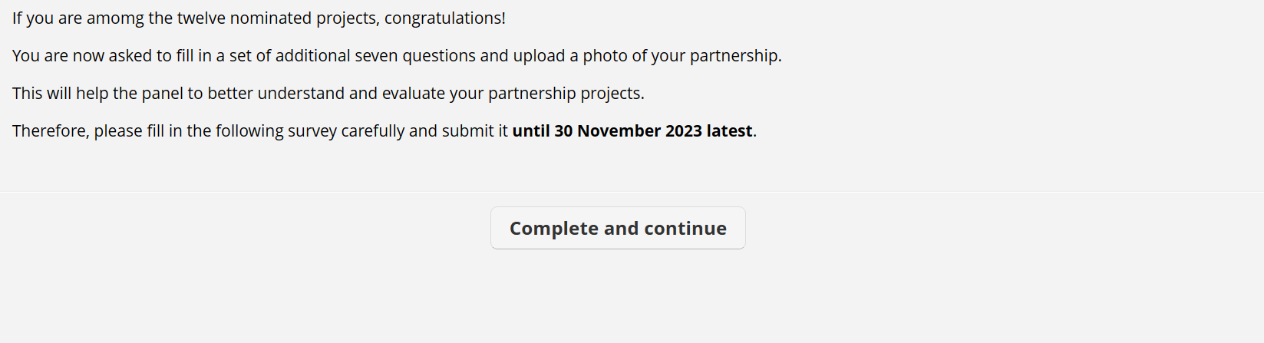

Click “Complete and continue” if you agree.

***2. Full Application Questions***

Please describe the **vision** of your partnership: What is the change the partnership wants/ wanted to bring about? *(Optional: In case you have a visualization/ image of your vision, you can upload it later in the process. Please make sure to describe it here first.)*

[vision, max. 1,000 letters]

***Ein Bild, das Text, Schrift, Grafiken, Grafikdesign enthält.
***

**Ein Bild, das Farbigkeit, Kreis, Grafiken, Kunst enthält.
**How does your partnership create **added value for all**, and how do you **measure progress and success**?

[value for all, progress measurement, max. 2,000 letters]

**Ein Bild, das Farbigkeit, Kreis, Grafiken, Kunst enthält.
**How did you **set up** your partnership? Please describe **how you engaged stakeholders**, and **with whom you work/worked closely** to implement the partnership

[partnership set-up, stakeholder engagement, max. 2,000 letters]

**Ein Bild, das Farbigkeit, Kreis, Grafiken, Kunst enthält.
**Which **collaboration structures** have you established, and how do these **contribute to deliver results** in your partnership? How/what do your **stakeholders contribute**?

[collaboration structures, delivery of results, stakeholders’ contributions, max. 3,000 letters]

**Ein Bild, das Farbigkeit, Kreis, Grafiken, Kunst enthält.
**Briefly describe your **governance/ steering structures** and **how you make decisions** in your partnership:

[governance structure, decision-making, max. 2,000 letters]

**Ein Bild, das Farbigkeit, Kreis, Grafiken, Kunst enthält.
**How do you **communicate and exchange** with each other in your partnership? Do you have an approach to ensure **joint** **learning**?

[communication, exchange, joint learning, max. 3,000 letters]

**Ein Bild, das Farbigkeit, Kreis, Grafiken, Kunst enthält.
**How does your partnership contribute to **larger sustainability transformation efforts**?

[sustainability transformation, max. 1,000 letters]

Click “Submit survey” to hand in your replies.

***3. Photo / graphic upload***

Ein Bild, das Text, Schrift, Electric Blue (Farbe), Reihe enthält.

Click “Upload a file” for your photo / graphic upload. Eligible formats are png, jpg, jpeg, gif.

***4. Full Application submitted***

* What was the innovation and/ or unique added value that was only possible to be achieved in this partnership?
* What was you biggest challenge, and how did you address it?
* Why do you consider this partnership a contribution to sustainability?

***Ein Bild, das Text, Screenshot, Schrift, Algebra enthält.
6. Nomination submitted***

***Ein Bild, das Text, Schrift, Grafiken, Grafikdesign enthält.
***Confirm “Complete” to submit your application.